**CyberArk LAB**

Please Follow below steps for LAB creation

1. Go to <https://training.cyberark.com/learn/signin> and click on “CyberArk Technical community Login”

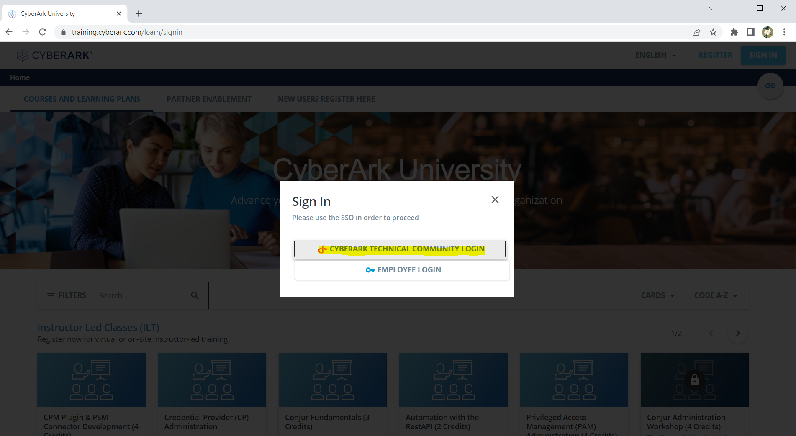

1. Then Click on “Sign Up as Learner”  
   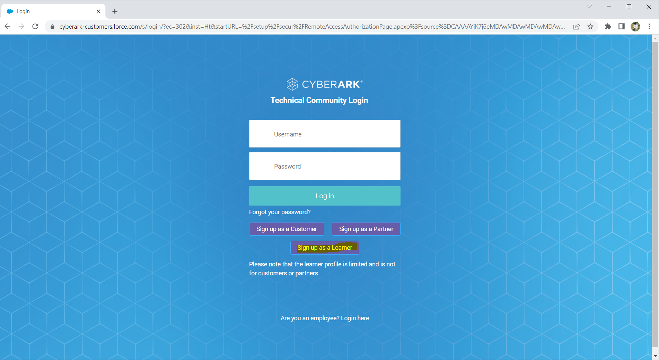
2. Fill the Country ,Language and Email details

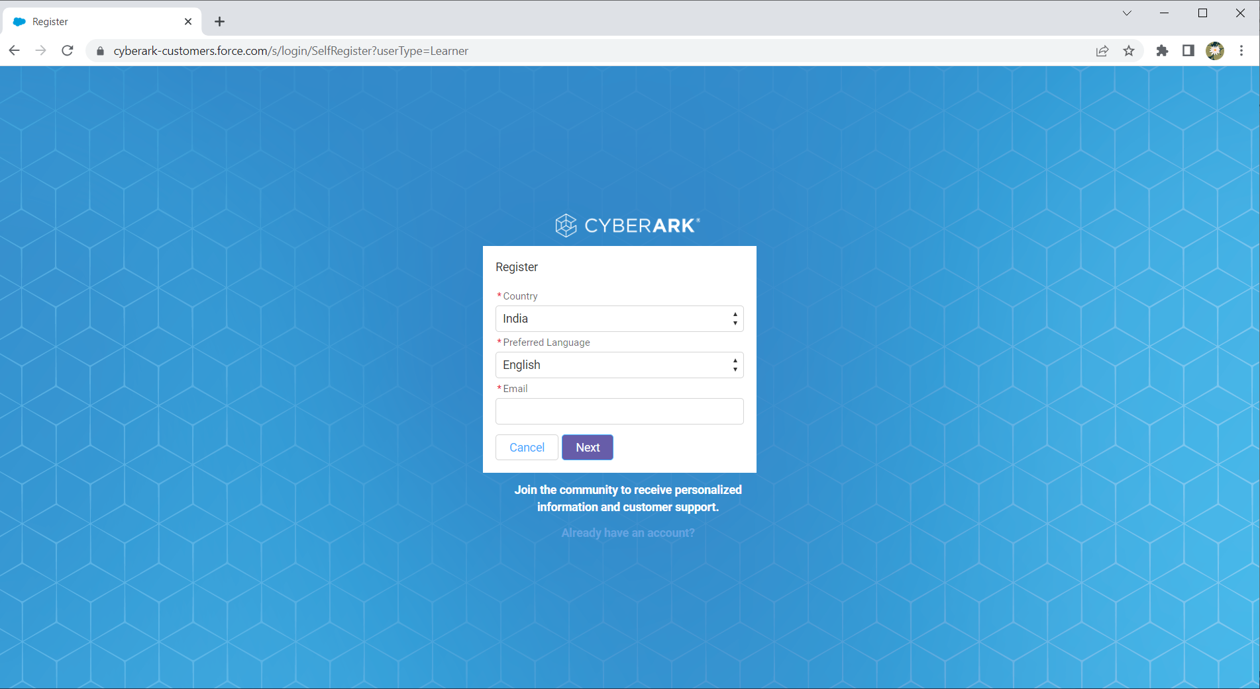

1. Enter your Gmail and other details in the below page and click on next

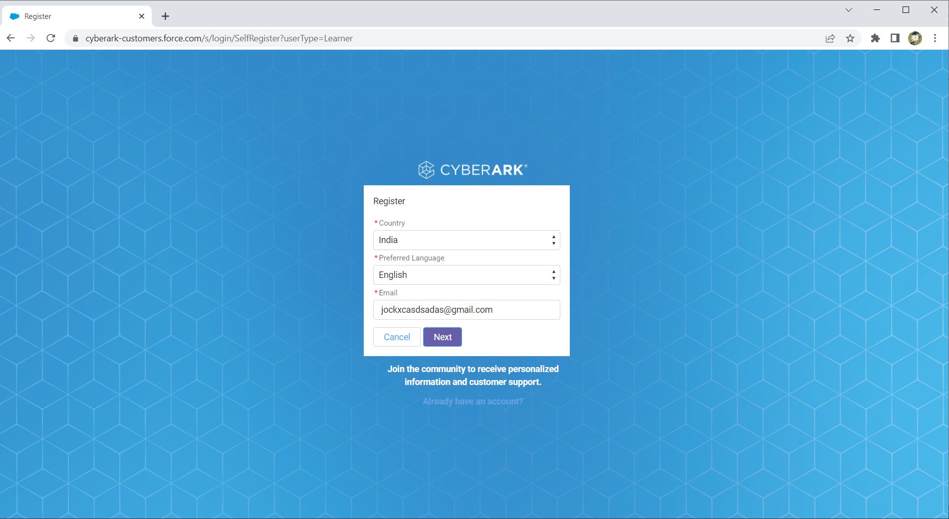

1. Enter the details 🡪 click the Checkbox 🡪Next  
   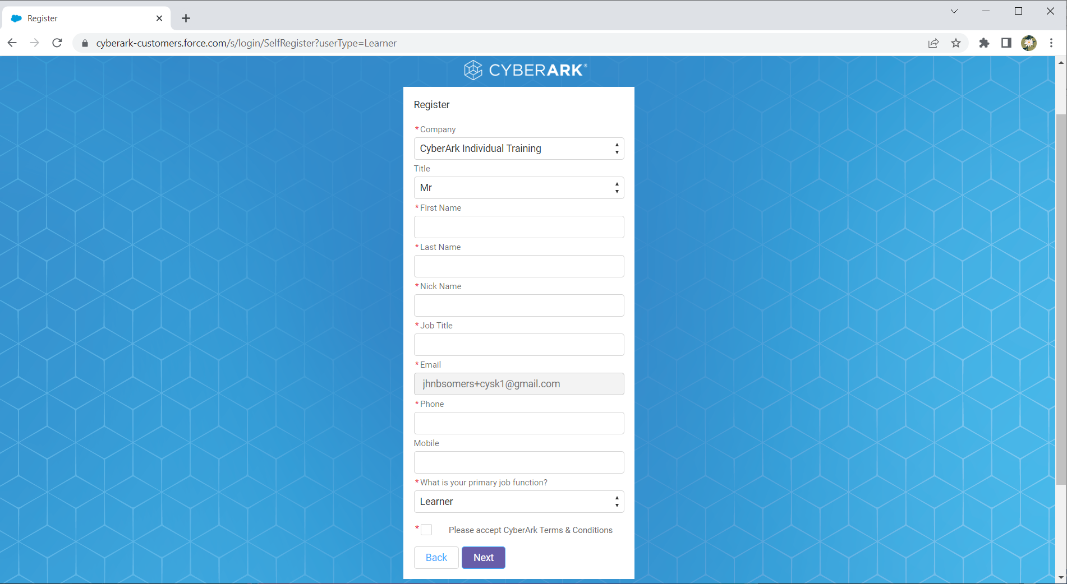

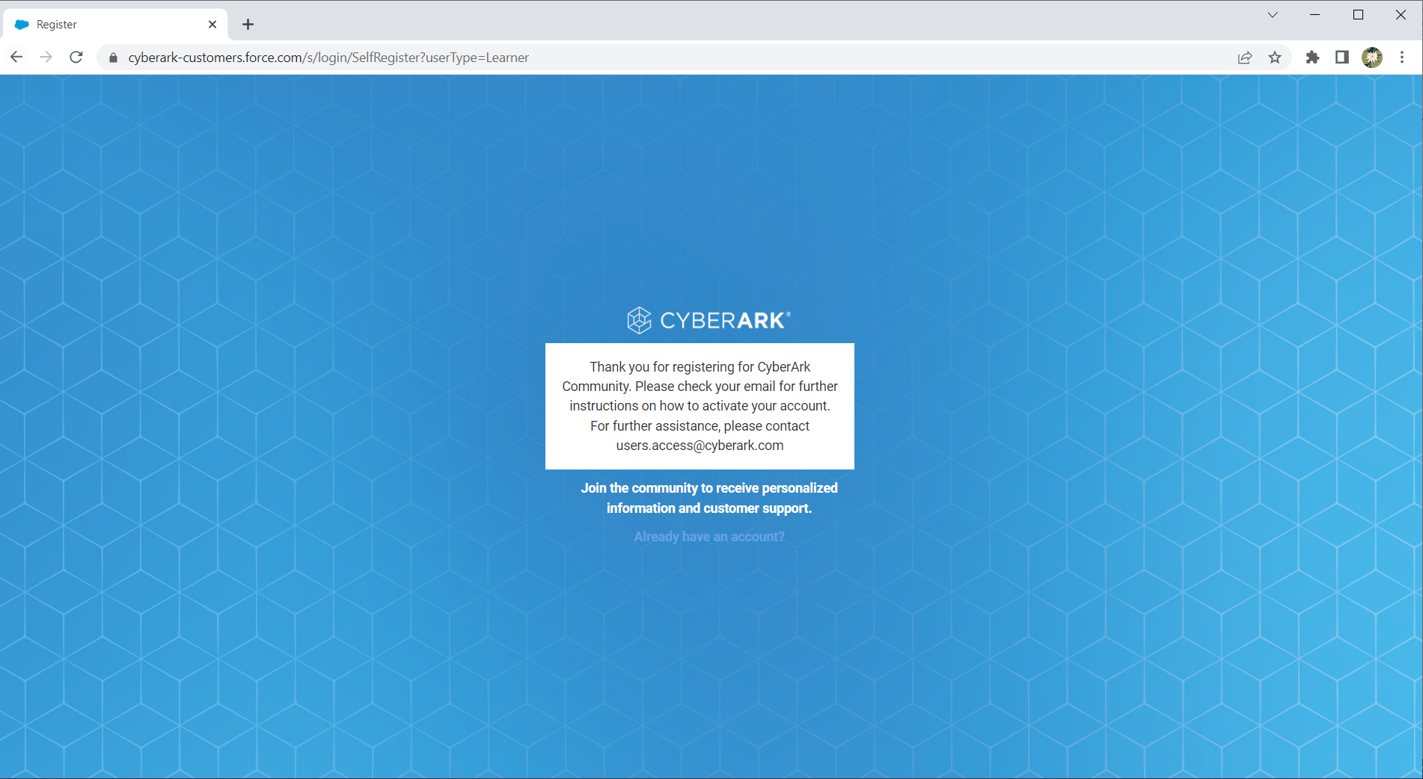

1. Check the Gmail for the mail received from CyberArk Support team and then open the URL mentioned in the mail and set the password for your account
2. Click on Addition Details 🡪 CyberArk University  
     
   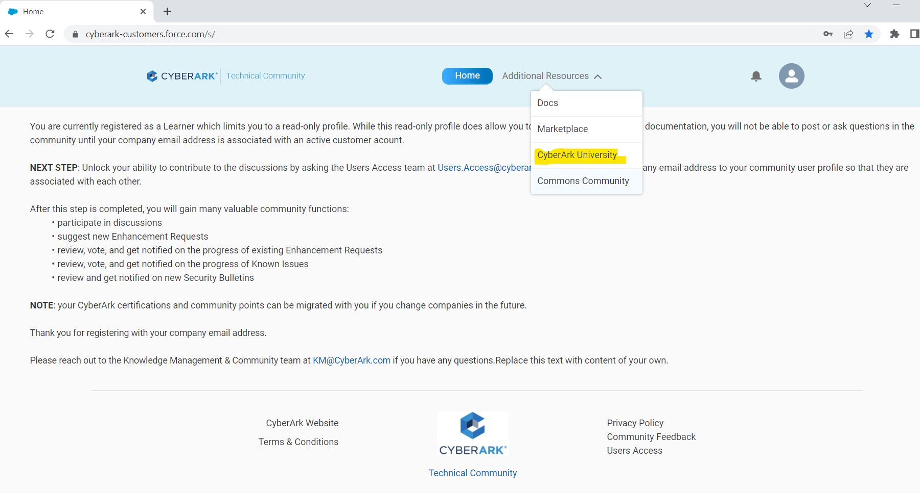
3. Once logged in search for the below courses and enroll it.

* *PTA Install and Configure*
* *HA Clustering - Install and Configure*
* *CyberArk Remote Access Install and Configure*

For example: 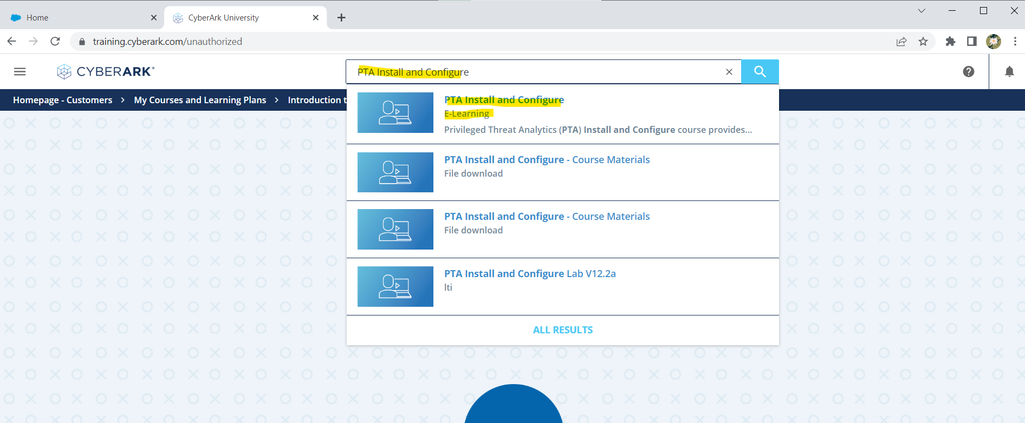

1. Enroll the course   
   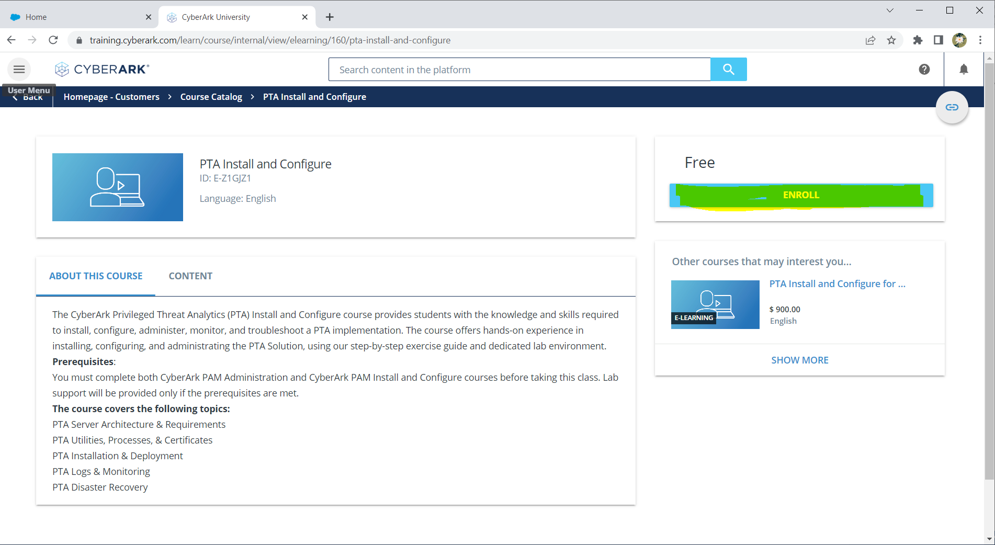
2. Click on View My Courses  
     
   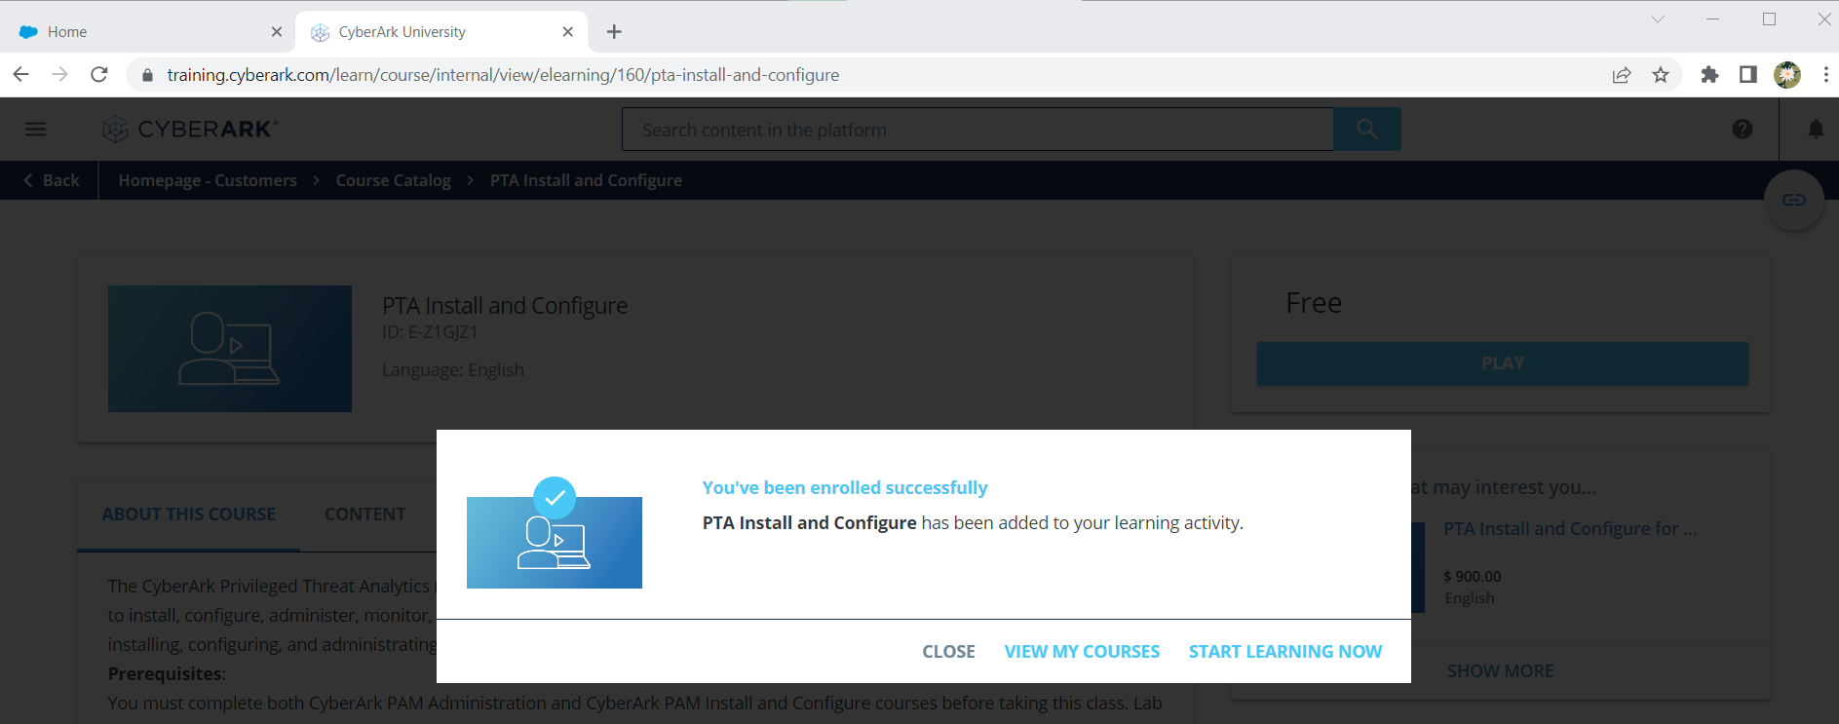

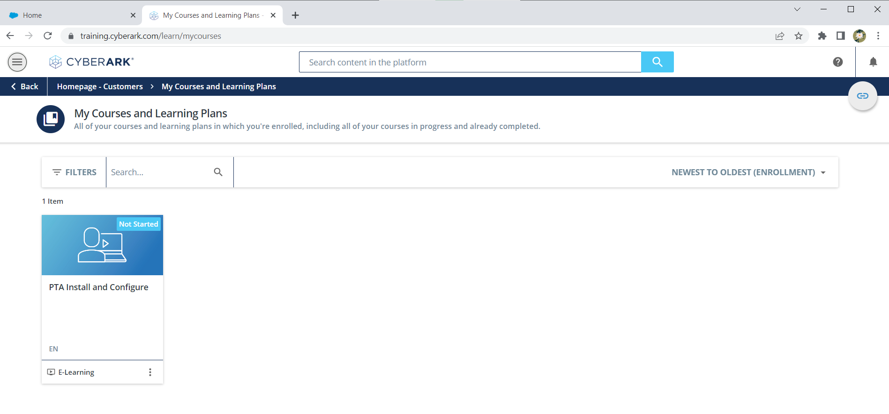

10 ) Click on the Course and click on “Start Learning NOW”   
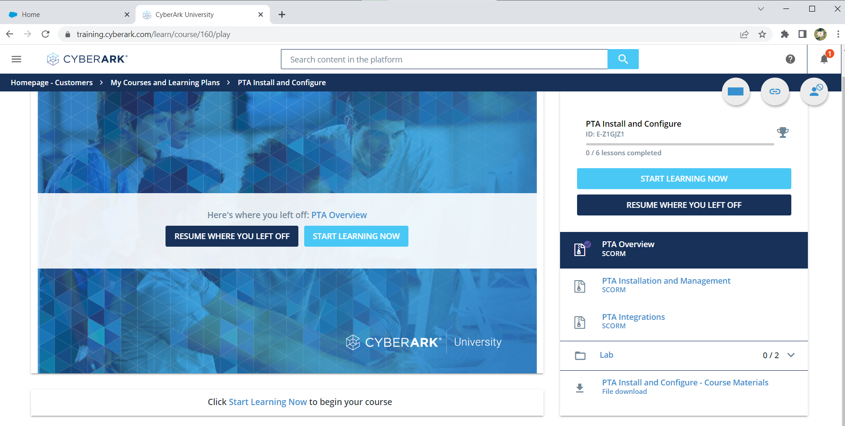

1. Click on the PTA Install and Configure LAB V12.2

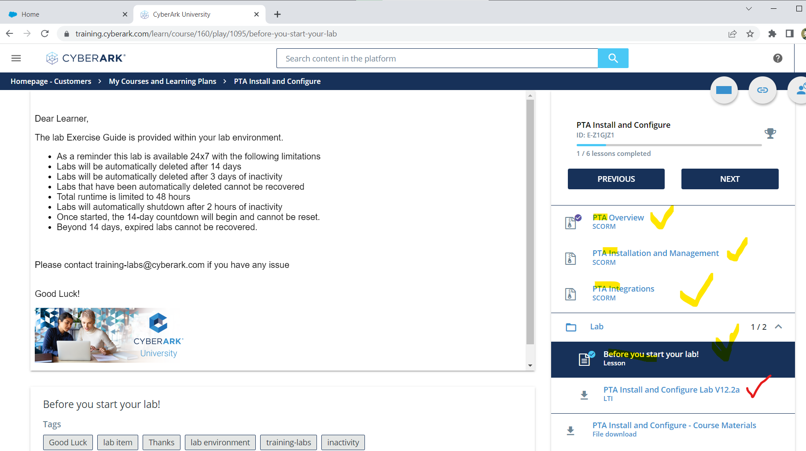

**Note: in other two Labs the learning Materials (Marked in yellow) should be completed in order to access the LAB.**

1. Now Click on Launch to start the LAB .it may take 10 – 15 minutes to provision your LAB.

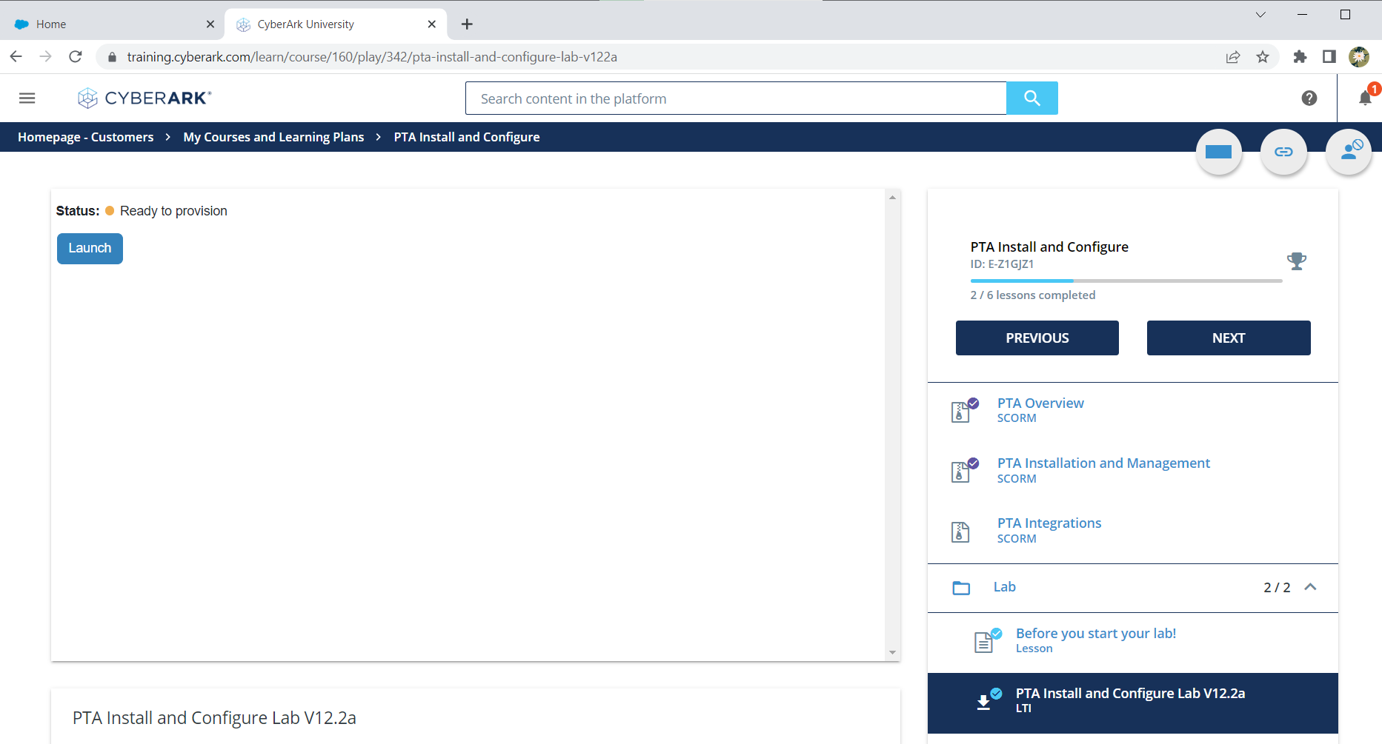

1. once LAB is provisioned click on Launch again

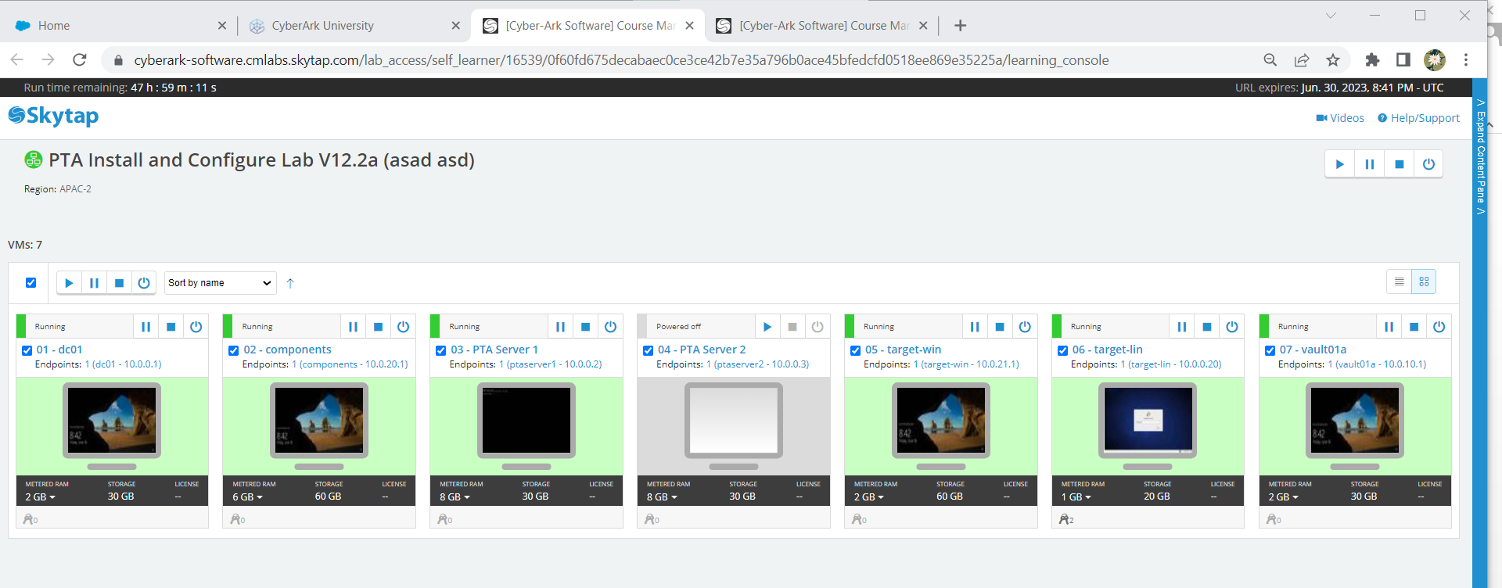

Always use Run and Shutdown option to Stop/start the LAB .DONOT use Power or Suspend option



**Follow the same process for getting below LABS**

Search for “***HA Clustering - Install and Configure”*** and enroll the course and follow the same process mentioned above  
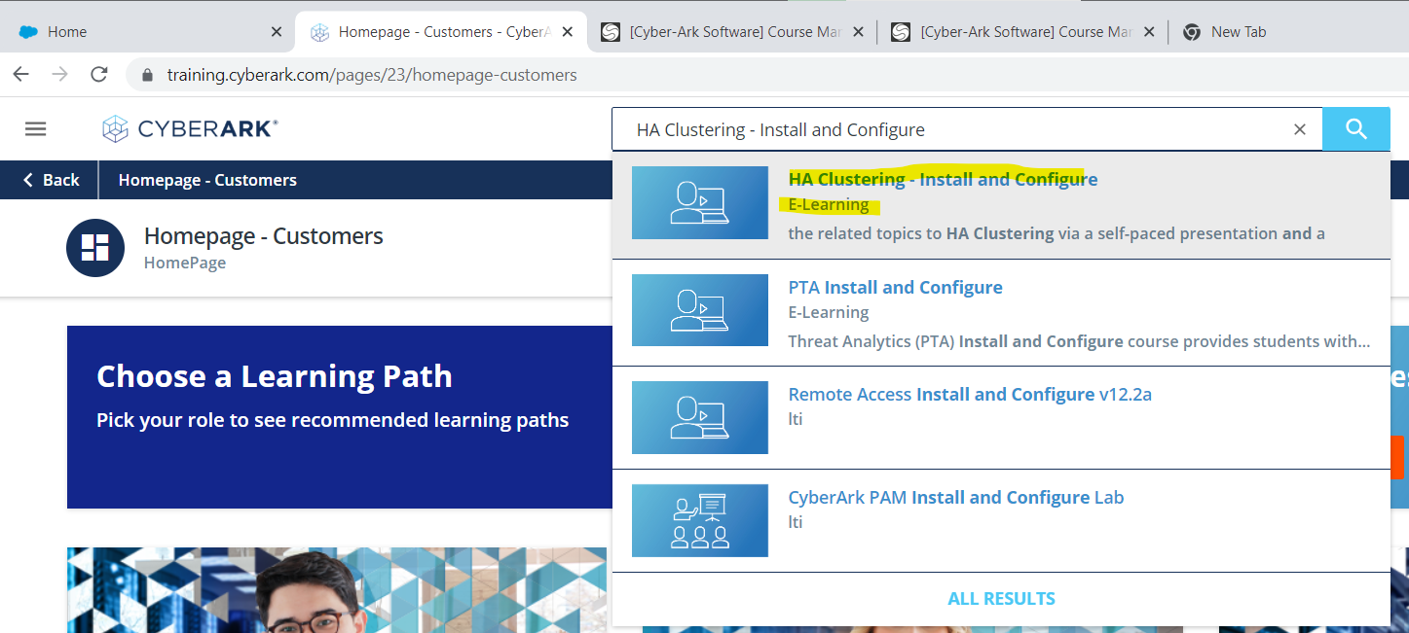

Search for “***CyberArk Remote Access Install and Configure***” and enroll the course and follow the same process mentioned above  
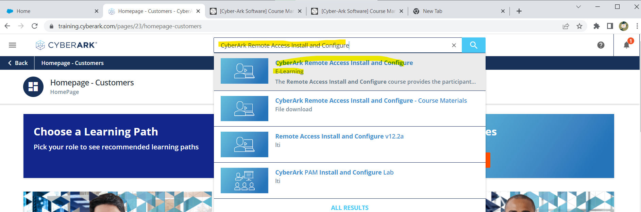

***Temporay Gmail Generator***

Use the below Link to Generate the Temporary Gmail for account creation.

<https://tempmail.dev/en/Gmail>

Once you received the mail from CyberArk please use the link received in the mail and set the password.

